Math 1 Name ____________________________  
**6-4 – 6-5 Triangle and Parallel Lines Proofs Review** Date_________

In problems 1 – 5, use the properties of triangles you studied to answer the given questions.

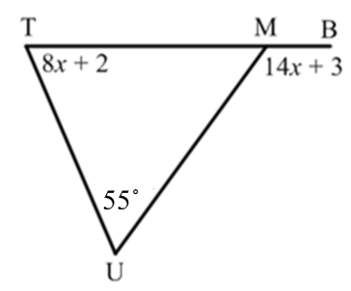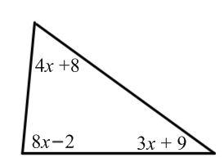1. Solve for *x*. 2. Find the 

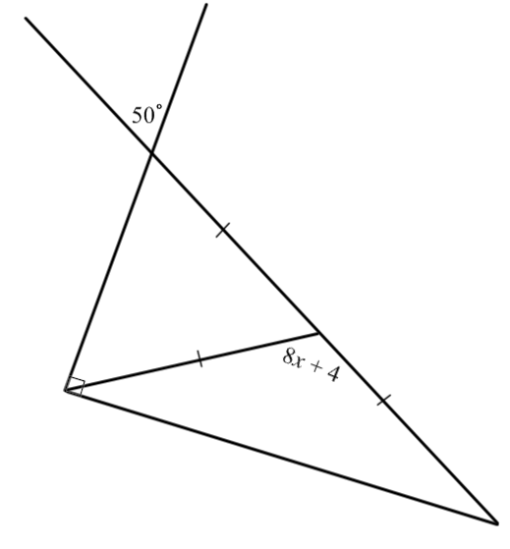

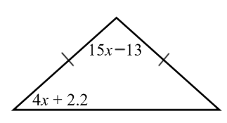3. Solve for *x.* 4. Solve for *x*.

5. Could you draw a triangle with side lengths of 22, 28, 50? Explain how you know.

6. Could you draw a triangle with side lengths of 20, 28, 15? Explain how you know.

7. Find the range of possible measures for the third side of a triangle with side lengths of **15 and 8.***Show your work and circle your final answer.*

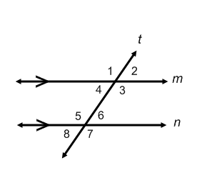

8. Given: Line *m* is parallel to line *n* with transversal *t*.

Prove: 

(Don’t use Alternate Interior Angles Theorem)

**STATEMENT** **REASON**

9. Given: Line *m* is parallel to line *n* with transversal *t*.

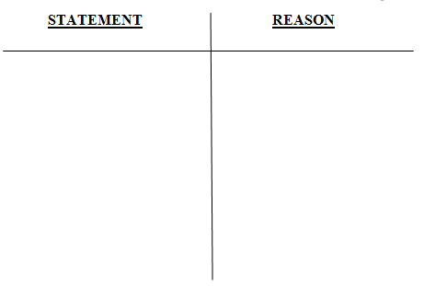 Prove: 

10. Given: Line *m* is parallel to line *n* with transversal *t*.

Prove: 

 (Don’t use Same-Side Exterior Angles Theorem)

10. Given: Line *m* is parallel to line *n* with transversal *t*.

Prove: 

 (Don’t use Alternate Exterior Angles Theorem)